**ASSIGNMENT 1**

**CSA0593- DBMS**

**S. Deva priya**

**192311419**

**QUESTION: Financial Risk Management System for Stock Portfolios  
Develop a database to manage stock portfolios, trading histories, and risk analytics for financial advisors.  
Requirements:  
Create tables for clients, portfolios, stocks, transactions, and risk assessments.  
Write procedures to calculate portfolio risk scores based on historical performance and stock volatility.  
Write SQL queries to identify high-risk portfolios and suggest risk mitigation strategies.  
Implement partitioning for performance optimization with high-volume transaction data.**

**1.Clients Table**

Stores details about each client.

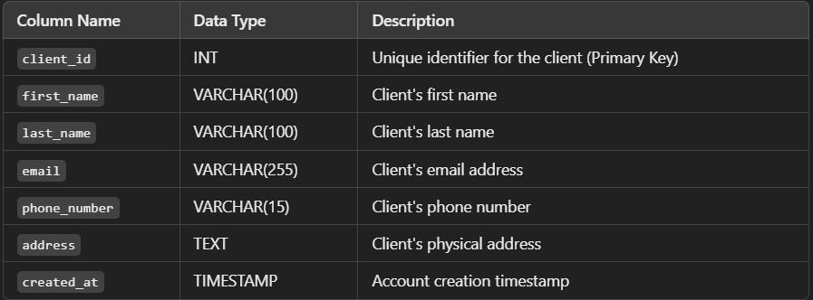

2.Stocks Table

Stores details about individual stocks.

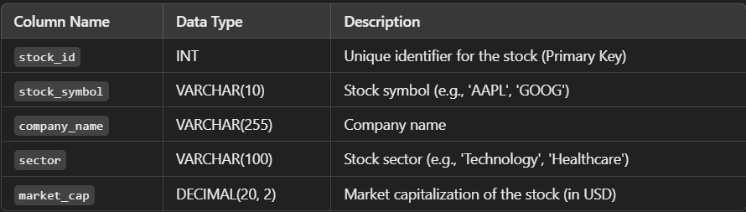

3.Portfolios Table

Stores information about portfolios associated with each client

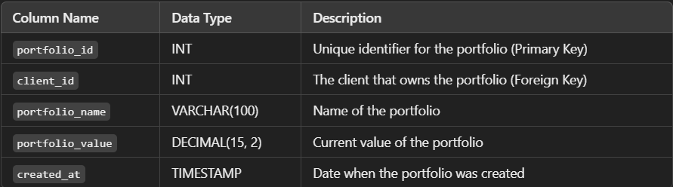

4.Transaction Table

Tracks all stock transactions (buy/sell) within a portfolio.

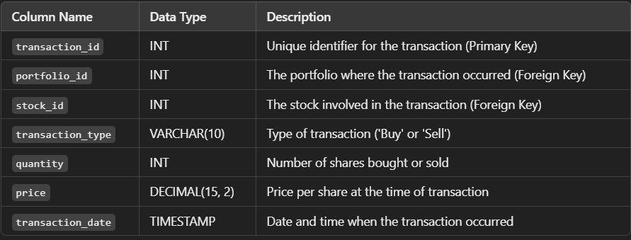

5.Risk assessements Table

Stores calculated risk scores for each portfolio, based on historical stock performance and volatility.

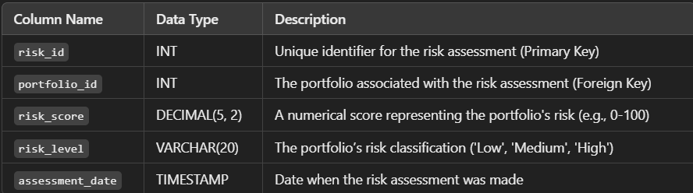

SQL CODE:

1.CREATE DATABASE TABLE:

-- Creating the Clients table

CREATE TABLE Clients (

client_id INT PRIMARY KEY,

name VARCHAR(100),

email VARCHAR(100),

phone VARCHAR(20)

);

-- Creating the Portfolios table

CREATE TABLE Portfolios (

portfolio_id INT PRIMARY KEY,

client_id INT,

name VARCHAR(100),

created_at DATE,

FOREIGN KEY (client_id) REFERENCES Clients(client_id)

);

-- Creating the Stocks table

CREATE TABLE Stocks (

stock_id INT PRIMARY KEY,

ticker VARCHAR(10) UNIQUE,

sector VARCHAR(50),

volatility FLOAT -- Volatility as a measure of risk (e.g., standard deviation of returns)

);

-- Creating the Transactions table

CREATE TABLE Transactions (

transaction_id INT PRIMARY KEY,

portfolio_id INT,

stock_id INT,

transaction_date DATE,

transaction_type VARCHAR(4), -- 'BUY' or 'SELL'

quantity INT,

price FLOAT,

FOREIGN KEY (portfolio_id) REFERENCES Portfolios(portfolio_id),

FOREIGN KEY (stock_id) REFERENCES Stocks(stock_id)

);

-- Creating the Risk_Assessments table

CREATE TABLE Risk_Assessments (

risk_assessment_id INT PRIMARY KEY,

portfolio_id INT,

risk_score FLOAT,

assessed_at DATE,

FOREIGN KEY (portfolio_id) REFERENCES Portfolios(portfolio_id)

);

2.CREATE SCORED PROCEDURE FOR RISK SCORE FACTOR:

CREATE PROCEDURE CalculateRiskScore()

BEGIN

DECLARE portfolioVolatility FLOAT;

-- Clear previous risk scores

DELETE FROM Risk_Assessments;

-- Calculate and insert new risk scores for each portfolio

INSERT INTO Risk_Assessments (portfolio_id, risk_score, assessed_at)

SELECT

p.portfolio_id,

SUM(s.volatility * t.quantity) / SUM(t.quantity) AS risk_score, -- Weighted average volatility

CURDATE()

FROM

Portfolios p

JOIN

Transactions t ON p.portfolio_id = t.portfolio_id

JOIN

Stocks s ON t.stock_id = s.stock_id

GROUP BY

p.portfolio_id;

END //

DELIMITER ;

3.IDENTIFY HIGH RISK PORTFOLIOS:

-- Define a high-risk threshold, e.g., 0.7 (adjust based on risk tolerance)

SET @high_risk_threshold = 0.7;

-- Query to find high-risk portfolios

SELECT

ra.portfolio_id,

c.name AS client_name,

ra.risk_score,

p.name AS portfolio_name

FROM

Risk_Assessments ra

JOIN

Portfolios p ON ra.portfolio_id = p.portfolio_id

JOIN

Clients c ON p.client_id = c.client_id

WHERE

ra.risk_score > @high_risk_threshold;

4.SUGGEST RISK MITIGATION STRATEGIES:

SELECT

p.portfolio_id,

c.name AS client_name,

s.ticker AS high_volatility_stock,

s.volatility,

t.quantity

FROM

Portfolios p

JOIN

Clients c ON p.client_id = c.client_id

JOIN

Transactions t ON p.portfolio_id = t.portfolio_id

JOIN

Stocks s ON t.stock_id = s.stock_id

JOIN

Risk_Assessments ra ON p.portfolio_id = ra.portfolio_id

WHERE

ra.risk_score > @high_risk_threshold

AND s.volatility > (SELECT AVG(volatility) FROM Stocks);

5.IMPLEMENT PARTITIONING FOR PERFORMANCE OPTIMIZATION:

-- Partition Transactions table by year for efficient querying

ALTER TABLE Transactions

PARTITION BY RANGE (YEAR(transaction_date)) (

PARTITION p_before_2020 VALUES LESS THAN (2020),

PARTITION p_2020 VALUES LESS THAN (2021),

PARTITION p_2021 VALUES LESS THAN (2022),

PARTITION p_2022 VALUES LESS THAN (2023),

PARTITION p_future VALUES LESS THAN MAXVALUE

);